**EXPERIMENT TITLE**

We want to set up the protocol of Routing & then we want to transfer data between two networks.

**EQUIPMENTS/SOFTWARE**

Cisco Packet Tracer:

There I need the following equipment: Router PT, Switch, Copper Cross Connection, Copper Straight Connection, Fiber Connection, End devices.

**PROCEDURES**

1. First of all I've opened Cisco packet tracer & logged in.

2. Then I took a pc & connected it with a switch by using a copper straight connection. Similarly I took several PCs’ & connected them with several switches by using copper straight as well as the previous one & I took Router PT & connected switch with copper straight.

3. After that, I took 3 servers & named them as DHCP,DNS & HTTP. & connected them with a switch.

4. Then I connected all the routers by using fiber among them. I selected gig 4/0 & 5/0 sequentially (from left to right). After that it'll look like this.

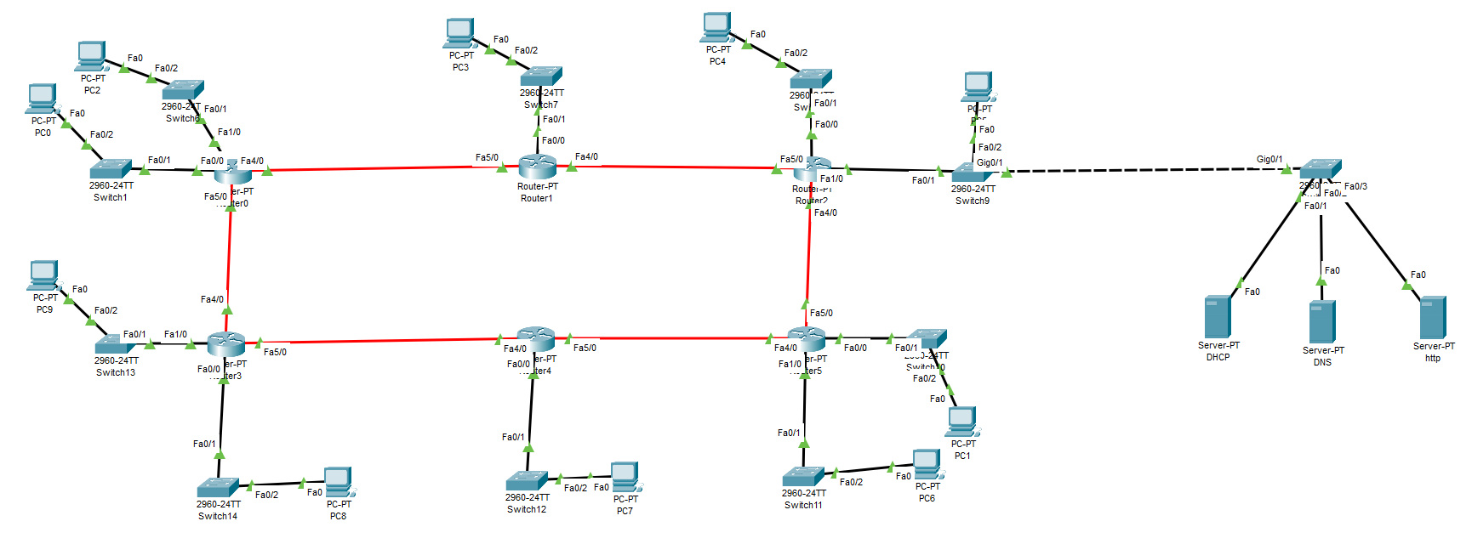

5. Then I connected the DHCP ends’ switch with the network side switch by using Copper Straight.

6. Then I configure the IP addresses & subnet masks according to this table.

|  |  |  |  |  |  |  |
| --- | --- | --- | --- | --- | --- | --- |
| **No** | **Fast 4/0** | **Fast 5/0** | **Subnet Mask** | **Fast 0/0** | **Fast 1/0** | **Subnet Mask** |
| Router 0 | 10.10.10.1 | 10.10.10.22 | 255.255.255.252 | 192.168.1.1 | 192.168.2.1 | 255.255.255.0 |
| Router 1 | 10.10.10.5 | 10.10.10.2 | 255.255.255.252 | 192.168.3.1 |  | 255.255.255.0 |
| Router 2 | 10.10.10.9 | 10.10.10.6 | 255.255.255.252 | 192.168.4.1 | 192.168.5.1 | 255.255.255.0 |
| Router 3 | 10.10.10.21 | 10.10.10.18 | 255.255.255.252 | 192.168.9.1 | 192.168.10.1 | 255.255.255.0 |
| Router 4 | 10.10.10.17 | 10.10.10.14 | 255.255.255.252 | 192.168.8.1 |  | 255.255.255.0 |
| Router 5 | 10.10.10.13 | 10.10.10.10 | 255.255.255.252 | 192.168.6.1 | 192.168.7.1 | 255.255.255.0 |

7. Then I opened each routers’ CLI tab& configured the RIP routing by using these comments;

> enable

Router# show ip route

Router# conf t

Router# router rip

Router# router version 2

Router# no auto-summary

Router# network {here i’ll put all all the network addresses)

Router# end

8. After that, I configured the Ip addresses of DNS, DHCP & HTTP

Here, Ip addresses are

DNS = 192.168.5.254

DHCP=192.168.5.253

HTTP =192.168.5.252

9. Therefore, where it remains by default turned off, I need to turned on all servers & routers after configuring it.

10. Thus my Routing process is finished. & i check if it is working or not by using ping destination network address & by browsing PC’s web browser.

**RESULT**



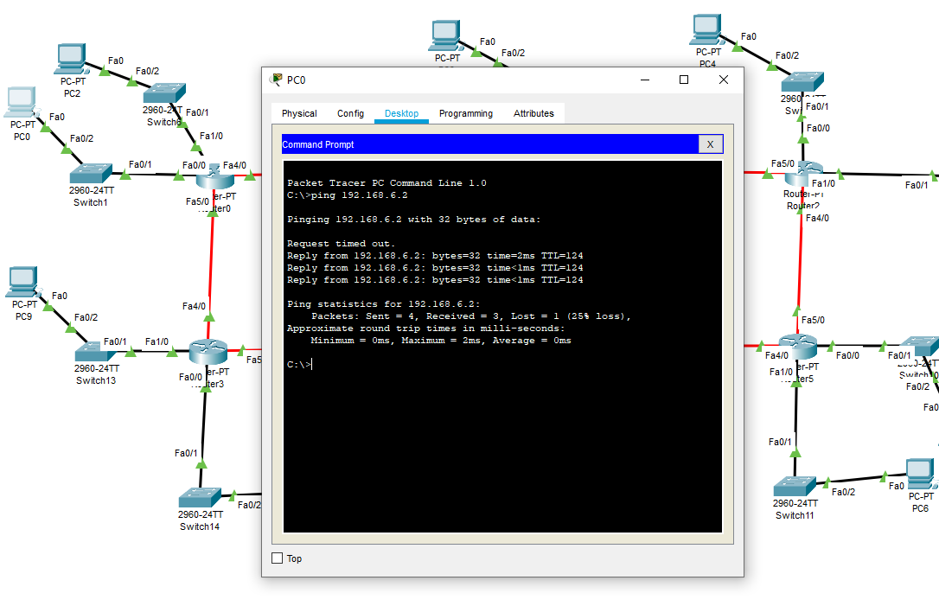

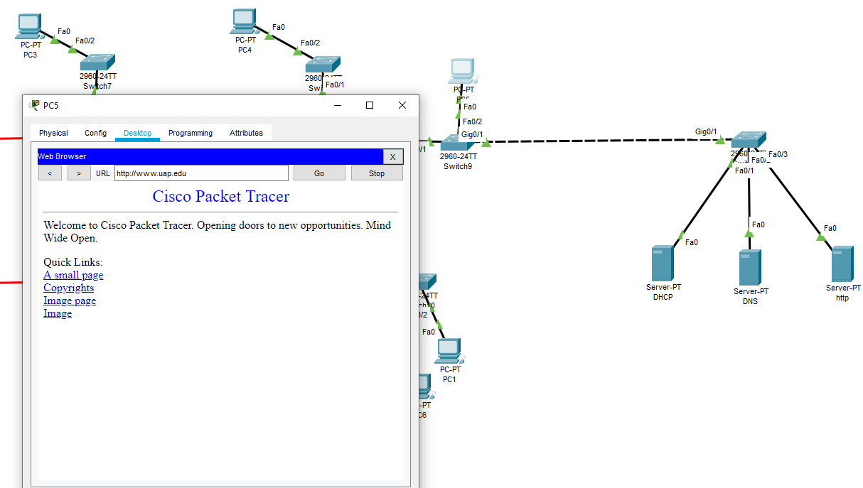

**CONCLUSION**

After this experiment we can now make a routing protocol.

We also learned about DHCP, DNS & HTTP & how this works.